Create the EC2 instance in Mumbai region. Create keys and security groups so as to remote login

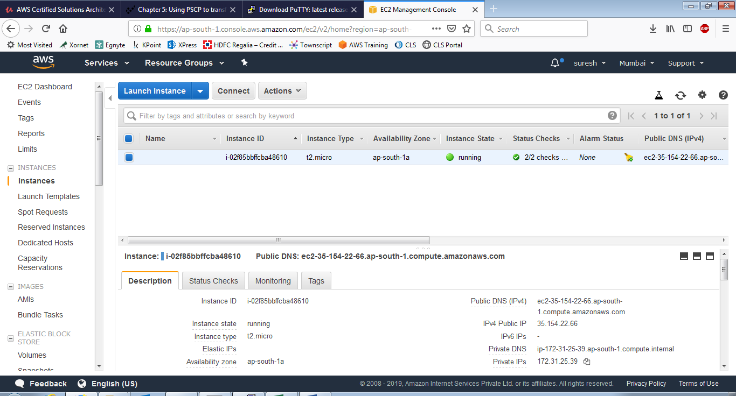

Login using putty

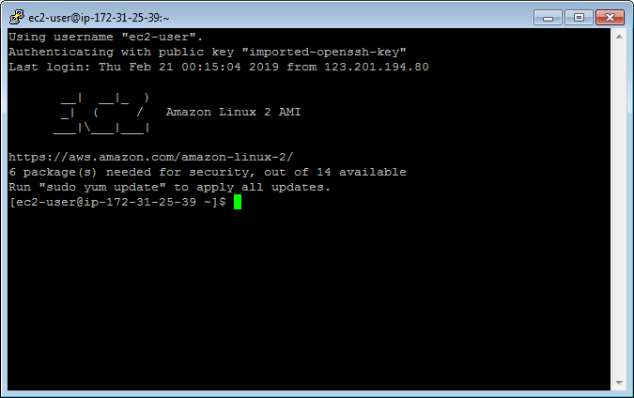

Try out a pscp file transfer both ways

